Take Your Seat In the Pitman’s Parliament

***Please note that due to the closure of Redhills for a major programme of restoration and renewal, you will not be able to view your token on your sponsored seat until Redhills reopens in Spring 2023***

To sponsor a seat at Redhills: Durham Miners Hall please complete this form. If you have any questions, please contact us by email to admin@redhillsdurham.org, or by telephone on 0191 3868413.

Payment
Please send us your details so we can prepare an invoice and receive your payment. Payments can be made via cheque, cash, or online transfer. Please specify your preferred payment method below.
Each sponsorship costs £100. Your token will be embedded in the seat of your choice in the Pitman’s Parliament. A duplicate token in a presentation box will be posted to you. Additional duplicate tokens can be purchased for £15 each.

Full Name

Address

Phone no.

Email

Preferred payment method

Colliery name, or seat number, you’d like your token embedded (please leave blank if no preference)

Your Pit Token
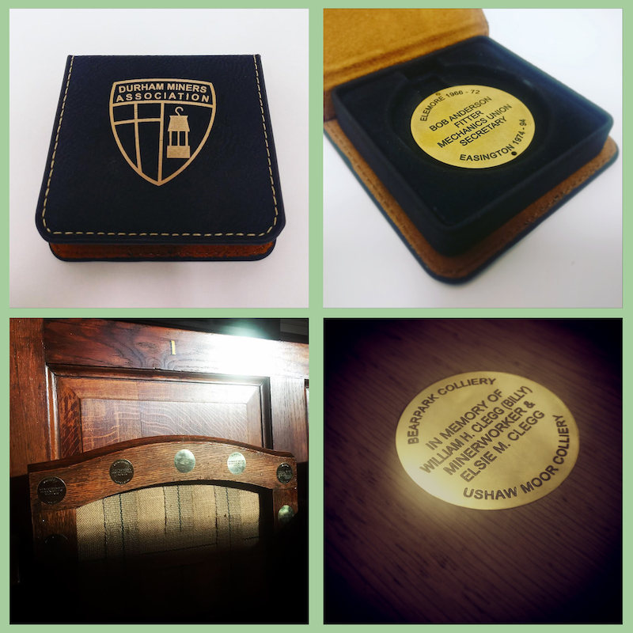
A commemorative token, engraved with your requested message, will be embedded in the seat you are sponsoring. You will also receive a duplicate of the token in a Durham Miners’ Association presentation box.
Your Message

Each token has a maximum number of characters, including spaces, that can be included per line. Please note we cannot exceed the number of characters specified below but you do not need to utilise each line or the maximum number of characters.
Please detail your requested message below. All messages will be checked for message length, grammar, inappropriate content etc. In the event your message is too long, or we have concerns about its content we will contact you to ensure a suitable arrangement is agreed.

Top Line (Maximum 15 characters including spaces)

Central message (Maximum 50 characters including spaces)

Bottom Line (Maximum 20 characters including spaces)

If you would like any additional duplicate tokens, please enter the number you require here:

